Experiment No. 5
Aim: To implement shallow and deep parsing techniques for analyzing the grammatical structure of sentences.
Code:
Step 1: Check for the Python version
python --version
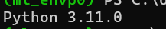

Step 2: Download the important libraries
# Download required NLTK resources
nltk.download('punkt')
nltk.download('punkt_tab')
nltk.download('averaged_perceptron_tagger_eng')

Output:
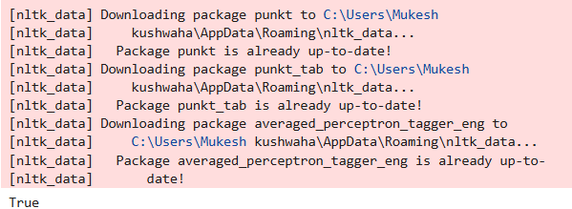

Step 3: Import the required modules
import nltk
import spacy
from nltk import CFG
from nltk.parse import ChartParser
from spacy import displacy

Step 4: Define the input sentence
sentence = "The little boy eats an apple in the garden."

Step 5: Tokenization and POS tagging
tokens = nltk.word_tokenize(sentence)

print("TOKENS:")
print(tokens)

pos_tags = nltk.pos_tag(tokens)

print("\nPOS TAGS:")
for word, tag in pos_tags:
print(word, "->", tag)

Output:
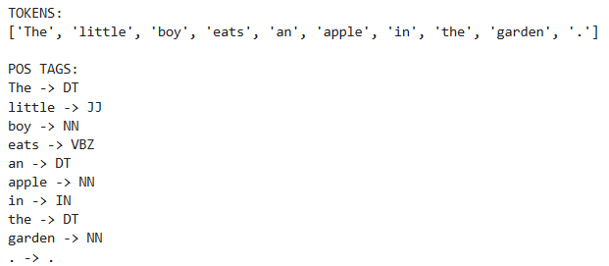

Step 6: Shallow Parsing
# Identify basic phrase-level structures
shallow_grammar = """
NP: {<DT>?<JJ>*<NN>}
PP: {<IN><NP>}
"""

shallow_parser = nltk.RegexpParser(shallow_grammar)

shallow_tree = shallow_parser.parse(pos_tags)

print("\nSHALLOW PARSING:")
print(shallow_tree)

print("\nSHALLOW PARSE TREE:")
shallow_tree.pretty_print()

Output:
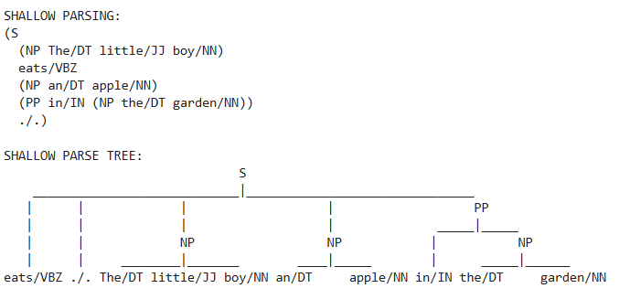

Step 7: Chunking
# Define rules for different types of chunks
chunk_grammar = """
NP: {<DT>?<JJ>*<NN>}
VP: {<VB.*><NP>}
PP: {<IN><NP>}
"""

chunk_parser = nltk.RegexpParser(chunk_grammar)

chunk_tree = chunk_parser.parse(pos_tags)

print("\nCHUNKING:")
print(chunk_tree)

print("\nCHUNK TREE:")
chunk_tree.pretty_print()

Output:
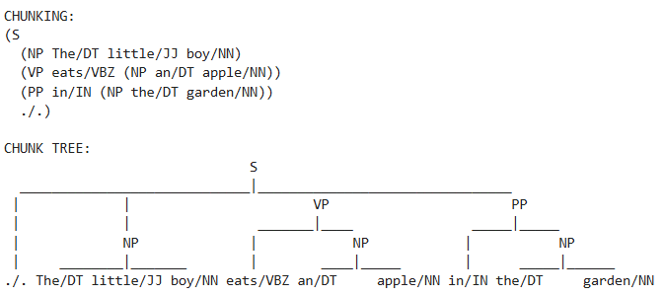

Step 8: Deep parsing / Dependency Parsing
# Load spaCy English model
nlp = spacy.load("en_core_web_sm")

# Process the sentence
doc = nlp(sentence)

print("\nDEEP PARSING / DEPENDENCY PARSING:")

for token in doc:
print(
f"Word: {token.text}, "
f"POS: {token.pos_}, "
f"Tag: {token.tag_}, "
f"Dependency: {token.dep_}, "
f"Head: {token.head.text}"
)
Output:
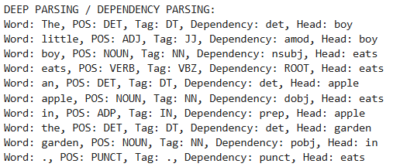

print("\nDEPENDENCY TREE:")

displacy.render(
doc,
style="dep",
jupyter=True
)

Output:
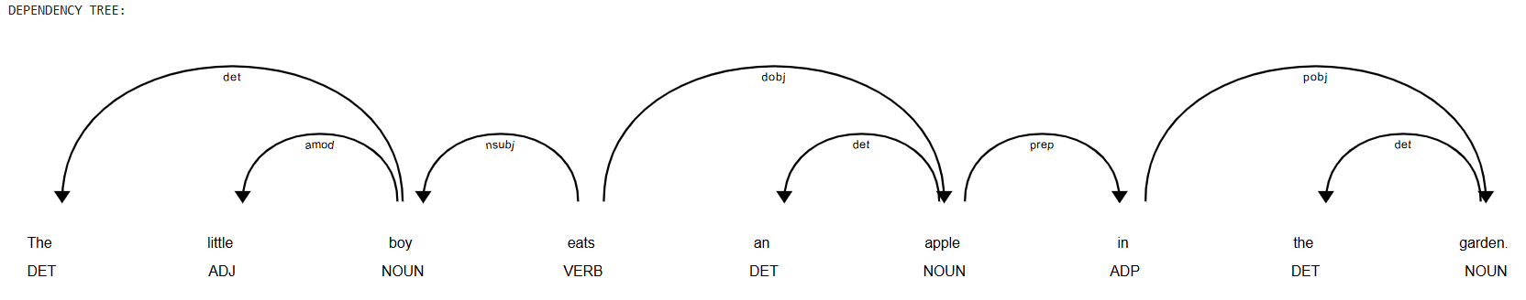

Step 9: CFG based parse tree generation
cfg_grammar = CFG.fromstring("""
S -> NP VP PP PUNC
NP -> DT NN
NP -> DT JJ NN
VP -> VBZ NP
PP -> IN NP

DT -> 'The' | 'an' | 'the'
JJ -> 'little'
NN -> 'boy' | 'apple' | 'garden'
VBZ -> 'eats'
IN -> 'in'
PUNC -> '.'
""")

parser = ChartParser(cfg_grammar)

cfg_tokens = nltk.word_tokenize(sentence)

print("\nCFG-BASED PARSE TREE:")

for tree in parser.parse(cfg_tokens):
tree.draw()

Output:
